**Easy Modular Equipment and Character System  
v1.0**

This system allows for quick and easy setup of modular game characters in the Unity inspector, supporting different body parts and equipment configurations.

**Installation & Quick Start:**  
  
1. Make sure the *EquipmentSystemInspectorGUI* script is placed in the *Assets/Editor* folder.  
  
2. Attach the *EquipmentSystem* script to the character(s) you want to use the system for.  
  
3. Attach the *Equipment* script to each equipment game object. Make sure that all of these objects are child objects of the character object. Setup the script values as you need.

4. If you want to use a modular body for your character, attach the *BodyPart* script to each body part you want to use. If you plan to use both, full body and body parts (e.g. you may want to switch between), you also need to attach the *FullBody* script to the full body object as well.

**System Description:**In the following the 3 scripts of the system and their usage are described.

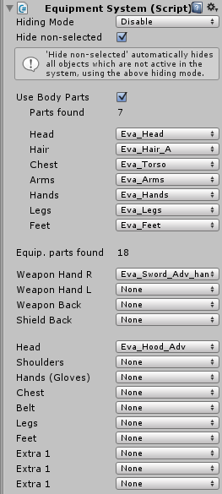**Equipment System (script)**

This script must be attached to the *root game object* of the character for who you want to use equipment or body parts. The script automatically detects equipment and body parts if they are child objects and if they have the proper scripts attached (*Equipment*, *FullBody*, *BodyPart*).

The *hide non-selected* option allows to hide all objects (equipment, body parts) which are not currently selected. You can use *Hiding mode* to specify if hiding shall set objects inactive or just disable their renderers. Note that if this option is turned off, all recognized equipment objects are always automatically set active with their renderers enabled.

For both body parts and equipment, slot categories are exclusive so that only one object can be active per slot at a time (e.g. you cannot wear two different head equipment pieces at the same time).

**Equipment (script)**

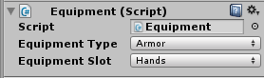This script must be attached to each particular equipment object you want to be recognized and managed by the equipment system. This script is also used to define type and slot of the equipment object. Note that all equipment pieces must be child objects of the root character object where the Equipment System is placed.

**BodyPart (script)**

This system supports easy setup of modular characters using different body parts. If you want to use body modules, this script needs to be attached to each body module object. In addition, the slot can be specified (e.g. *Head*, *Chest*, *Arms*, *Hands*, *Legs*, *Feet*).

**FullBody (script)**

If you want to use a character that may support both body parts and a full body, you need to put this script on the full body object so that it can be recognized by the system.

**EquipmentSystemInspectorGUI (script)**  
This script must be placed in the *Assets/Editor* folder. It controls the custom Inspector behavior for the system. There is no need to setup or change anything here.